RUGBY FIBROMYALGIA
SUPPORT GROUP

For more information:

Email:
fibromyalgiarugby@gmail.com

Website:
www.fibromyalgiarugby.wordpress.com

Call: 07812093605/07472079955
RUGBY FIBROMYALGIA SUPPORT GROUP

Loss of:
- Financial Stability
- Self Esteem
- Self-Confidence
- Social Life
- Self Worth
- Personality
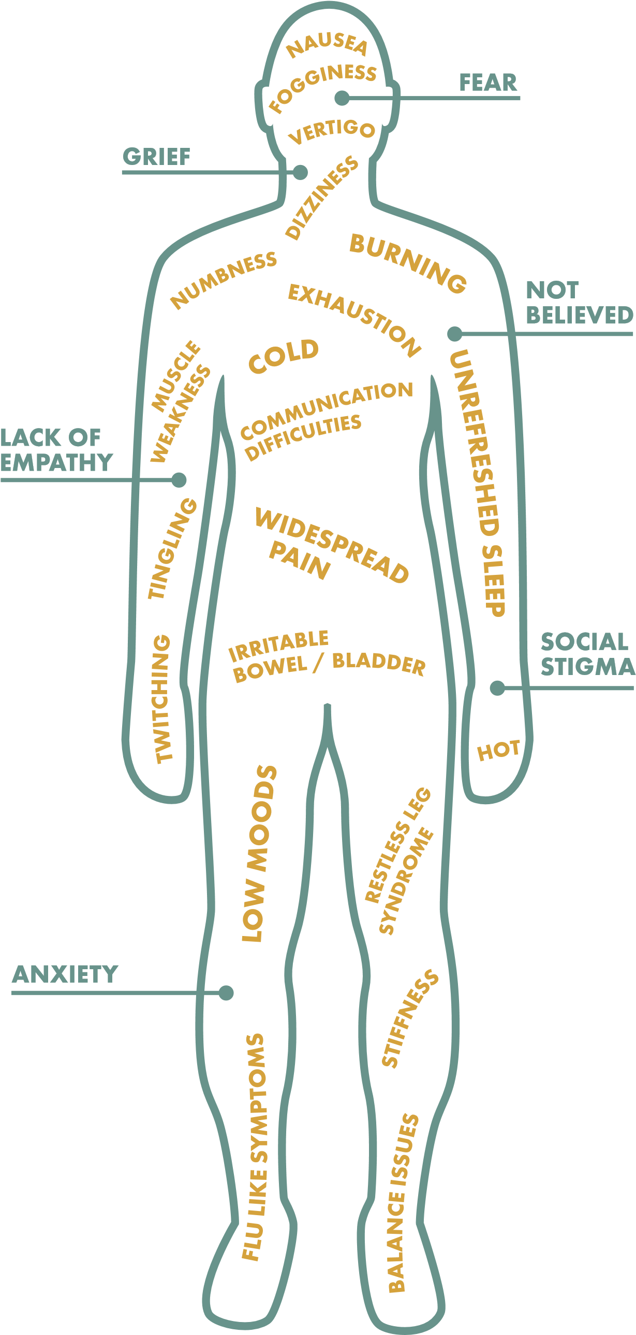
Rugby Fibromyalgia Support Group Meetings
Daytime Meetings:
Day: Second Wednesday of each month
Time: 12.00 mid-day until 1.30 pm
Location: King George iv Sports Pavilion.
Long Lawford
Next Dates: Wed 11th March 8th Apri
Come and make friends. Have fun .Find ways of living with the condition. Learn about new research and treatments. Partners and carers welcome. Don’t be alone

THE SYMPTOMS AND OUTCOMES OF

